

PROVIDER’S GUIDE FOR DOCUMENTATION

Outcomes & Services

SEPTEMBER, 2024

GEAUGA COUNTY BOARD OF DD

8200 Cedar Rd., Chesterland, OH 44026

[providersupport@geaugadd.org](mailto:providersupport@geaugadd.org) | 440.729.9406

# Contents

Overview 1

Documenting Outcomes & Experiences 2

Documenting Services & Supports 4

Documenting Time—Required 6

Other Tips & Reminders 7

# Overview

Providers shall maintain service documentation in accordance with rule 5123-2-08 and 5123-2-09 and service-specific rules in Chapter 5123-2 of the Administrative Code. Each provider shall maintain all service documentation in an accessible location. The service documentation shall be made available upon request for review by DODD, the Ohio Department of Medicaid, the Centers for Medicare and Medicaid Services, a county board or regional council of governments that submits to the department payment authorization for the service, and those designated or assigned authority by the department or the Ohio Department of Medicaid to review service documentation.

**"Service documentation"** means all records and information on one or more documents, including documents that may be created or maintained in electronic software programs, created and maintained contemporaneously with the delivery of services, and kept in a manner as to fully disclose the nature and extent of services delivered.

Service delivery documentation is **required** to validate all Medicaid waiver billing.

# Documenting Outcomes and Experiences

Outcomes are goals the individual values and wants to accomplish. Experiences are the ‘to do’ list to lead the individual to their overall outcome.

1. To determine the Experiences for which the provider is responsible review the

**Outcomes/Experiences** section of the OISP.

* 1. Read the outcomes thoroughly. There may be more than one outcome in the OISP. The provider responsible is identified in the **Who is responsible** column. Additionally, review the **What needs to happen**, **How should it happen**, and **When/How often** columns.

1. Transfer the details of the **Outcomes** and **Experiences** to the Service Delivery Documentation.
   1. Providers may create their own documentation form or may use the form created by GCBDD located at: https://[www.geaugadd.org/provider-resources/forms/](http://www.geaugadd.org/provider-resources/forms/)
   2. Each waiver service has specific documentation requirements. To ensure documentation meets the requirements, please reference rules at https://dodd.ohio.gov/forms-and- rules/rules-in-effect/administrative-rules-list for specifics based on service(s) provided.
   3. Providers are recommended to transcribe Outcome and Experiences verbatim to ensure compliance.
2. After completing an **Experience**, providers document by initialing on the date the action took place. Documentation must be completed daily as services are provided.
   1. Providers are not required to record other provider’s action steps that may be listed, nor are they responsible for them.
   2. Ensure services related to **Experiences** are being provided at the frequency indicated in the OISP.
   3. c. If an **Experience** is not being conducted per the frequency, explain why. Reach out to the SSA if the service plan needs revised.

**OISP Outcome/Experience Example**

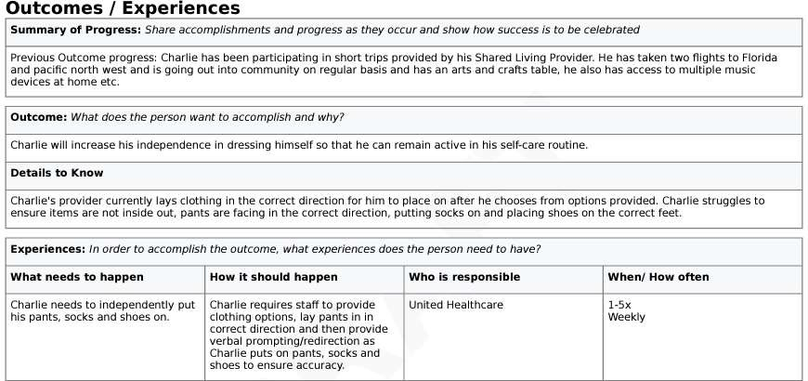

**Documentation of Outcome & Experiences examples**

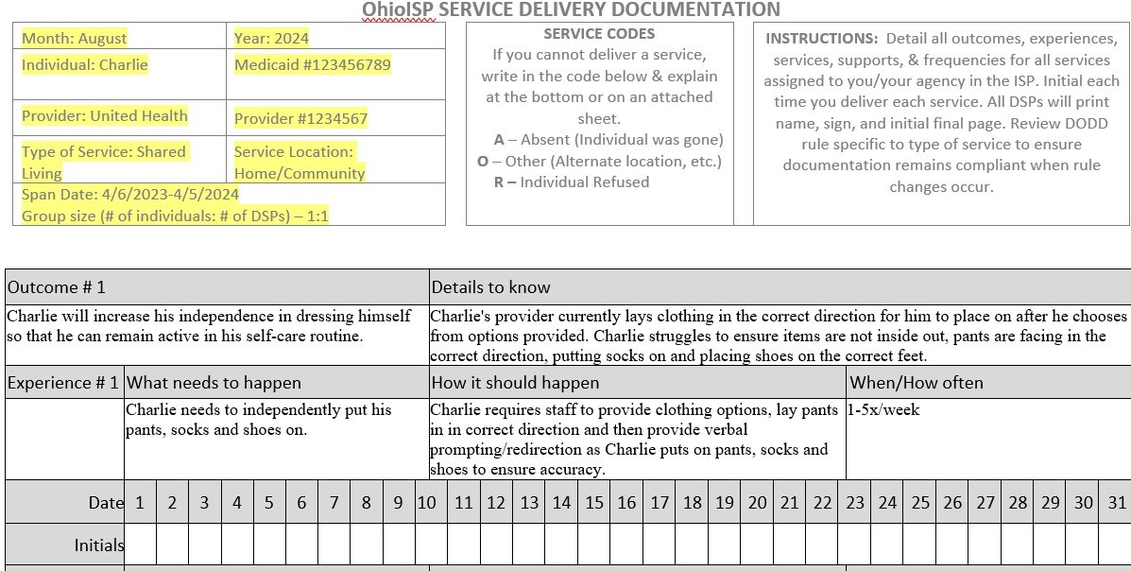

**Documenting Services and Supports**

Services and Supports are tasks such as activities of daily living, routines, supervision, community supports, etc. of which providers are responsible. Below is an example from an OISP of services and supports.

1. Transfer the **Scope of Service/What support looks like** listed in the support area and frequency listed in **How often?/How much?** to the blank documentation sheet.
   1. Initial under the services provided on the days they are provided.
   2. Be sure to complete tasks per frequency in the plan.
   3. If the provider is not completing a task as indicated in the OISP, then this should be indicated on the documentation form and the reasoning.
      1. For example, you could indicate “individual refused services” or “individual hospitalized.”
      2. If the individual is refusing services, providers are required to document that the service was offered. Providers should reach out to the SSA if the individual continually refuses a service.

**OISP Services and Supports Example**

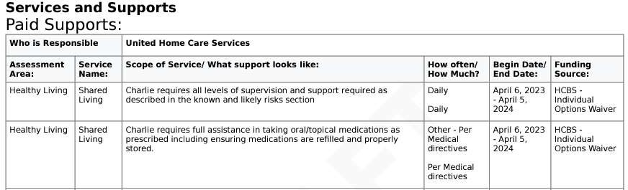

**Documentation of OISP Services & Supports example**

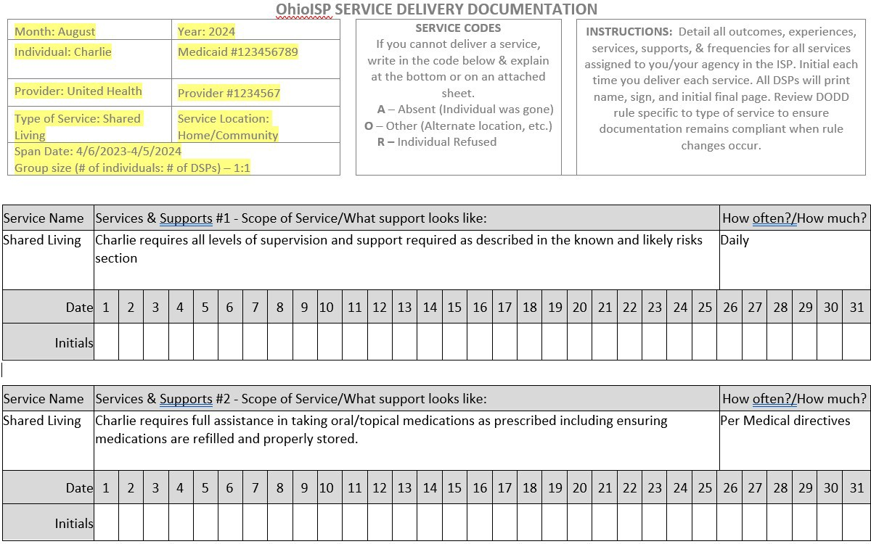

**Service Documentation Narrative example**

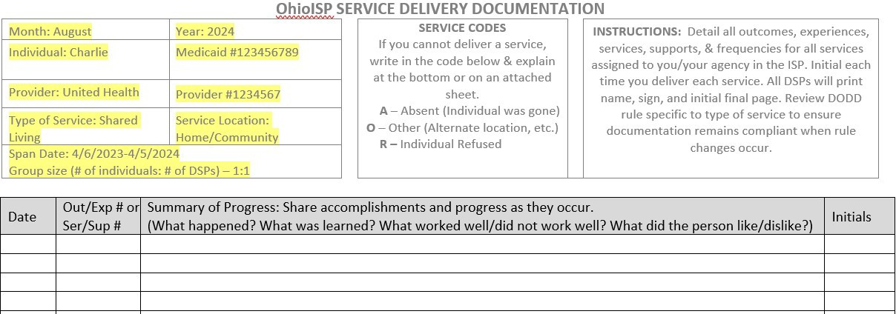

**Documenting Start/Stop Times of Services Provided**

1. Certain services require Providers to document time in/time out details. These services include Homemaker Personal Care, Participant Directed Homemaker Personal Care, Transportation, Informal Respite, etc. Please review the DODD Rule associated with the service you are providing to be sure if you are required to document start and stop times of services provided. Please note, Electronic Visit Verification is not accepted as sufficient time in/time out documentation by DODD’s Office of Compliance.

There is a document template available on Geauga County Board of DD website at <https://www.geaugadd.org/provider-resources/forms/.>

# Additional Documentation Requirements

* 1. Medication Administration—**required if provider administers medications**— Refer to the **Healthy Living** section of the OhioISP assessment. A medication administration record (MAR) may be necessary for providers passing medications. MARs are separate documents that some pharmacies offer to create for providers.
  2. Managing Personal Funds— **required if provider assists an individual with managing money**— Provider’s responsible for personal funds management are required to maintain separate documentation forms that can be found on our website. Providers should refer to the Personal Funds rule 5123:2-2-07 for more information on documentation requirements.
  3. UI Log- **required by all providers-** Required to be maintained and reviewed monthly even when no Unusual Incidents occurred.
  4. MUI documentation- **required by all providers.** Please refer to the MUI rules for details.
  5. **Required Restrictive Measure Documentation** for those with restrictions approved by the Human Rights Committee and in accordance with rule 5123-2-06.

# Other Tips & Reminders

1. Providers are required to be aware of all assessed needs and supports for each individual served. If there are any significant changes that need to be addressed, providers should reach out to the SSA and the individual’s team to request a Service Plan revision.
2. Review and update documentation as necessary when Service Plans are revised and updated. Revisions can happen anytime during the year upon individual request.
3. Providers are required to keep separate service delivery documentation for each individual served.
4. Documentation must be accessible and submitted upon request by SSA/GCBDD/DODD/Medicaid.
5. When billing for services provided, providers are required to maintain corresponding documentation demonstrating the provider was with an individual and providing an authorized service. Failure to do so could be considered Medicaid fraud. Records necessary to disclose fully the extent of the services provided must be kept for a period of six years from the date of receipt of payment or, if an audit has been initiated, until the audit is resolved, whichever is longer.

**\*\*\* Please contact the GCBDD provider support at** [**providersupport@geaugadd.org**](mailto:providersupport@geaugadd.org) **if you need assistance. \*\*\***