DODD – Possible or Determined MUI Report Form
Provider Name & Address
Individual’s Name: |  | DOB:
Address: |  | City/County:
Date of Incident: Time of Incident: AM/PM
Location of Incident (home in bathroom, at the mall, lunchroom at work):
Description of Incident (Who, What, Where, When):
Injury – Describe Type & Location:
Immediate Action to Ensure Health & Welfare of Individuals:
Name of PPI(s): | Relationship to Individual:
Witnesses to Incident: | Others Involved:
Type of Notification | Name/Title |  | Date/Time
Guardian / Advocate/Family
SSA
Licensed or Certified Provider
Staff or Family living at the Individual’s home
LE (Name, Badge Number, Jurisdiction, Contact Info)
Children’s Services (if applicable)
County Board
Administrator (Required for ICF)
Senior Management
Other Providers of Service

Additional Information/or Administrative Follow-Up: A. Further Medical Follow-up:

B. Administrative Action:

Printed Name:
Signature: Title: Date:

Body Part Injured:
0 Head or Face 0 Neck or Chest
0 Mouth / Teeth 0 Abdomen
0 Hands / Arms 0 Back / Buttocks
0 Feet / Legs 0 Genitals
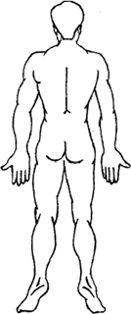
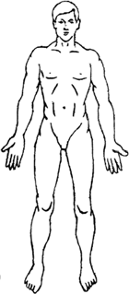
0 Other

Causes and Contributing Factors:

Preventive measures: (For Provider’s internal use)

Administrator Review:
Date:

DODD MUI UNIT INCIDENT REPORT DECEMBER 2018

